


Importance of choosing the right data visualization technique when comes to display important data.

Table of Contents

Contents
Importance of choosing the right data visualization technique when comes to display important data………………………………………………………………………………..01
Table of Contents.…………………………………………………………………….……..02
Student Declaration……………………………………………………………….……. …..03
Abstract………….…………………………………….………………………………….....04
Introduction….. ………………………………………………………………………….... .04
Background………………… ….………………………………………………………..….04
Which is more important when time comes to choose chart or line ……. ….……………....05
The Chart Making Process ………….………………………………………………………....05
Finding out what you want to say is sometimes the hardest part..….………………………….…..06
Why a picture is still worth a thousand words.…………………….…….…………….…....06

Examples of bad data visualization techniques used out there, critique how to fix them……...07
- Overuse of colour distract the reader and user from the actual data………………….…..07
- the whole chart jumps out at you. Here’s what’s confuse the reader as well user…….…08
- Colour, text, arrows!.....................................................................................................,.....09
- Convey information consistently while presenting your data …………………….…….10
- We all know colour has meaning — use it to convey your message!.................................11
- Make sure don’t make your user and readers think!..........................................................12
- Choose the right colour selection and size …………………………………………...…13

Conclusion………………………………………..………………………………...………14
Reference………………………………………………………………………………...…15

Student Declaration

I can confirm the following details:

Student ID/Registration Number : R00144214
Name : Mohammed Alom

Module Name: Interactive Data Visualisation
Module Lecturer: DR. Ruairi O’Reilly

I confirm that this is my own work.
Due Date: Monday 5th November 2018

Student Signature:

Signed: Mohammed Jahangir Alom
___________________

Importance of choosing the right data visualization technique when comes to display important data.

ABSTRACT:
In this article, I critique as a form of data visualization technique, especially focusing on different design style on qualities of critiques that are different such as colour, texture, style.

INTRODUCTION:
In this article I will try to find out about some of the data visualization technique are using these days either in business or individual for their day to day task in terms of choosing what colour, shape, visualization technique should they use and I will critic about on them and how those data can be redesigned in a better way so that it can be much more appealing to the audience and give more clear picture what is all about these data means to the audience and reader.

We are all probably aware that the best companies in the world have their a Data collection, Data Reporting, and Data Analysis teams or member (DC-DR-DA). When it comes to time, money and people: 15-20-65 percentage rule all well and good for the company. But there is one crucial part we often don't invest insufficiently. The last mile which is Data presentation. The actual output of this data almost singularly responsible for driving the change we want in our organizations to see in future.

BACKGROUND:
Before I do a critique of any data visualization, I wanted to share my view on creating a good data visualization. I am a student and currently studying on Software Development and one of the core subject is data visualization at the Cork Institute of Technology and as part of the course, I am covering quite lots of data visualization technique and what good and bad Patrice should follow. I would like to mention here that what I call "The Shaffer 4 C's of Data Visualization". They simply serve as a guideline to follow when creating or critiquing a data visualization.
The Shaffer 4 C's of Data Visualization:
- Clear - easily seen; sharply defined. Who's the audience? What's the message?
- Clean - thorough; complete; unadulterated. Example. not over labelling axis and data points, too many gridlines or too dark, proper formatting, using the right chart type, poor colour choice, etc.
- Concise - brief but comprehensive.
- Captivating - to attract and hold by beauty or excellence. Does it capture attention? Is it interesting? Does it tell the story?
I’ve seen some pretty horrible data visualization examples lately on the internet on a various company that are using data visualization technique to represent their company’s data that shall remain nameless as part of my assignment as well as course material. So, I started to educate myself on what good data visualization looks like, how chart size and subtle colour and position are excellent ways to convey information without screaming it at them. If you’re still using bright backgrounds on your graph — here’s looking at you, kid. You want a high data-ink ratio.
Here are some of the highlights I’ll discuss in this article:
- Using different colours wisely for the chart.
- Not adding junk chart to present your valuable data.
- Having a high data-ink ratio. Choosing right coloured backgrounds.
- Using the right type of graph to convey the information to reader.
- Understanding the meaning of particular colours, like red and green, and using them right place in right time to indicate problems and successes, respectively.
- Use element size, colour saturation, and positioning to convey information.

Which is more important when time comes to choose chart or line:

Confusion!! Bar chart or Line? Scatter plot or box plot? Which one to use and when these are the questions we ask ourselves often when we set out to make a chart. Because “Selecting the right chart for our data” is very important to tell our story.
Because the right graph or chart lead to the right decisions for the company. We use charts to tell our stories, assess alternatives, recognize trends or to figure out if everything is normal. So, when we select an incorrect char that can lead to a poor judgment of the messages whereas a correct chart can lead to right and faster decisions for the individual as well as the company.

The Chart Making Process:
Chart making and selecting process can be divided in to 4 steps-

- Find-out what you want to say?
- Rearrange the data
- Prepare the chart
- Format the chart

Finding out what you want to say is sometimes the hardest part:
This is the first and most important step in chart selection and preparation process. We need to ask ourselves, “what is the purpose of this chart all about?”. Once we know the clear reasons why the chart should exist in the first place, we will naturally be able to select the correct chart type for that particular reason.
But often realized that finding the reason itself can be a bit monotonous. So, here I have listed down six common reasons that we often have to make a chart:

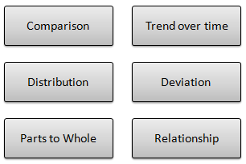
- to Compare
- to show the Distribution
- to explain Parts of the Whole
- to tell the Trend over time
- to find out the Deviations
- to understand the Relationship

Compared to many charts out there, including some of the examples below in this article here, those would be considered a pretty good chart. However, those charts can be improved when examining some of the finer design changes that can be made.

Why a picture is still worth a thousand words:
We have all heard the old proverb: “a picture is worth a thousand words”. One of the best techniques for understanding data is to visualize the numbers as a picture. You can visualize data in many different ways, from simple bar charts to more complex scatterplots. There is also no shortage of technical help: books have been written on visualizing data; there are scores of websites devoted to the subject, and there is a wide range of software and downloadable programs available for every purpose.

Here are some the examples of bad data visualization techniques used out there, critique how to fix them:

1. Overuse of colour distract the reader and user from the actual data:
Colour should be used properly in the chart because colour conveys more information. In my opinion this chart has many things wrong with it:
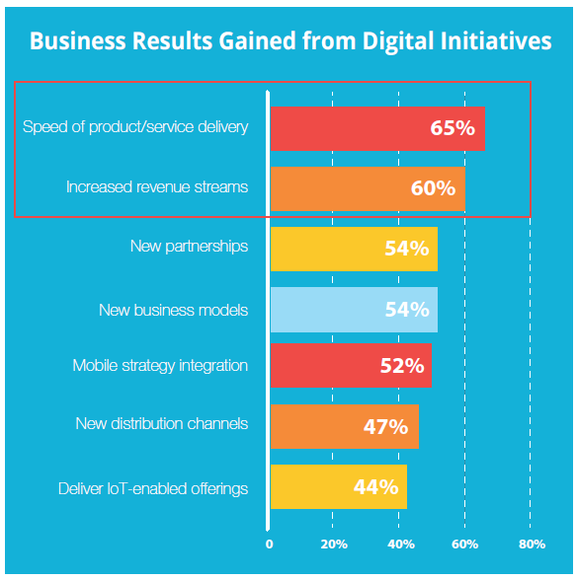
-Red is generally used to show an error, and orange a warning sign in the charts. But here Speed of product delivery is in red but represents in the chart biggest.
- Here, with this graph as if all the red was not enough to pass actual information, later a red box is added for some reason, which makes distracting the user and reader, even more so as there is nothing to show why that red box is there in the first place.
-A bright blue background colour further confuses the reader as well as the audience. Especially red, orange and yellow used for the attention grabber. When using those colours the eyes not to know what to focus on first glance. Users, audience, and reader end up jumping all over the place, instead of actually taking in the information you want them to.

Re-design the above chart:
- Here, I’ve changed to only the blue colour, changed the weight of the graph lines, removed the background colour white is the most readable for most users and reader and added a small curly bracket indicator to replace the red box, complete with text.
- Remember, the readers won’t spend the time to read your accompanying text and will only give your chart a quick glance to see if it has a merit to further study. You don’t have another chance to make a first impression! So, choose the right things in the right place.

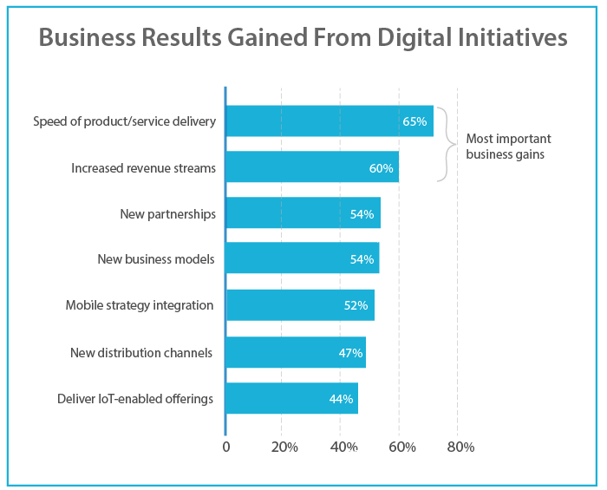
2. Here’s another example where the whole chart jumps out at you. Here’s what’s confuse the reader as well user:
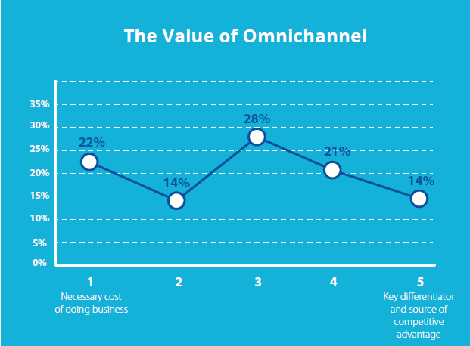
-Which is more important here? What information do you want the user to grab from the chart? Seems like everything is important here in the graph. All are bold.
-Bright blue background colour makes the whole thing vibrate to me and I believe the reader will find too.

The Redesign:
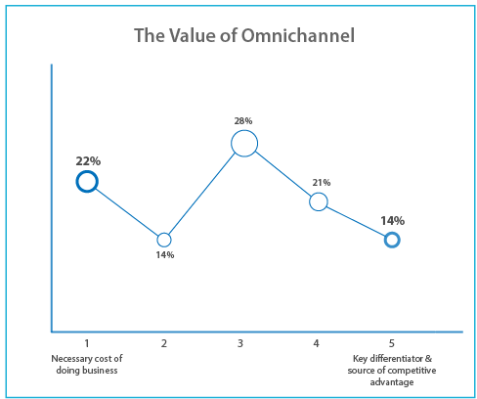
-Can see the difference between both charts now. I can see for sure. The above chart is redesigned simply to change the background colour taking out bold treatment and text were used to convey the important parts only.
-And round ball size was used to immediately convey differences in value in the graph.

3. Colour, text, arrows!:
-I personally cannot concentrate on this graph. There are many things that make the following chart difficult to understand.
-Two arrows coming down to the graph. I cannot figure out what is all about with these two arrows! Internal dept systems at 49% go to Customer supply chain at 36%? What?
-And why all the red and orange?! These colours are attention-grabbing in themselves, but against the blue background funny. They seem to the extrovert.
-Unnecessarily long labels Crazy long title used in the graph!

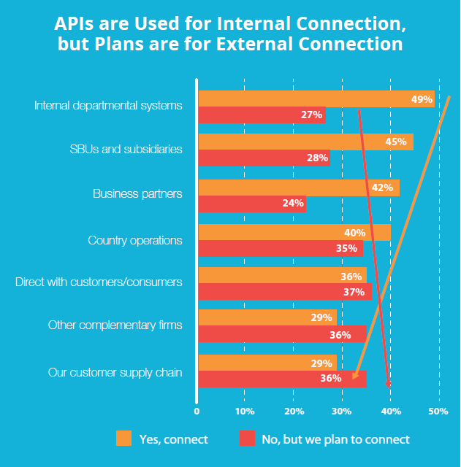

The Redesign the above chart:

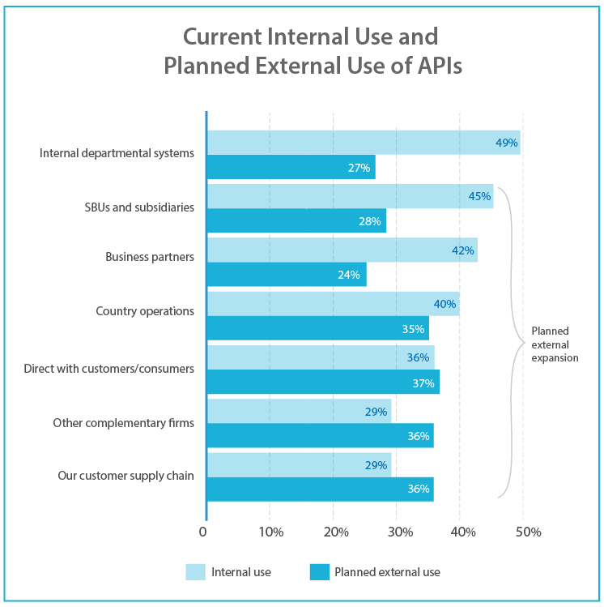
-Here, what I did first reduce the colours to just two, both shades of blue.

-where the external expansion is shown as more important compared with another one to draw attention to it.

-A simple curly bracket indicator is used to replace those mysterious arrows on the original chart.

-Title and label text are shortened to ease in reading and scannability.

4. Convey information consistently while presenting your data:
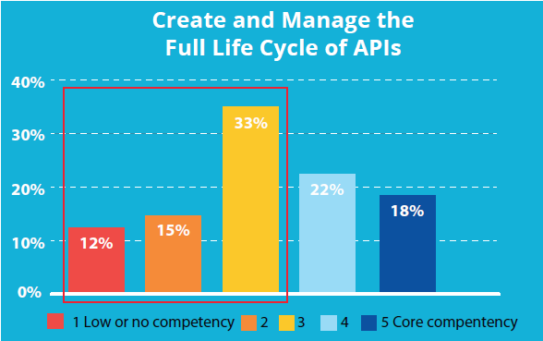
-We need to keep consistency. If we use one method to convey a scale, don’t use a different method the next time.
-You’ll probably recognize this line graph in an earlier example, but this one made even more complicated!
Here, besides the background and colours, which I’ve stressed on enough the red border, why it’s there?

-Another classic example the x-axis which is bold unnecessary here.

The Redesign the above chart:

First and foremost, to change the colour to saturation to convey the message and here it is. By using more light blue I convey meaning low to high competency.

Second, replace the mysterious red box from the graph and added curly bracket with text.
-Changed the background colour.

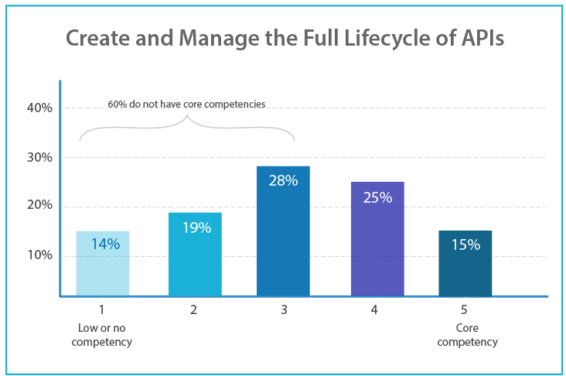
5. We all know colour has meaning — use it to convey your message! :

With this pie chart here, the most vital information is “not the no plans to section”, then yes then no makes whole pie chart very complicated. A user must scan the chart with the text at the same time. A bit complex for the user. Again, using red-orange all over the place to grab attention?

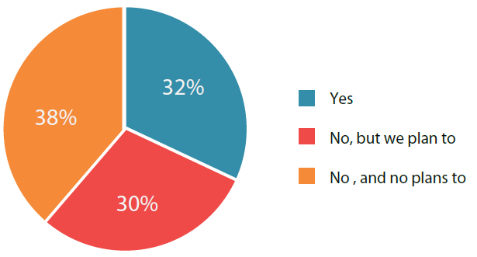
The Redesign:
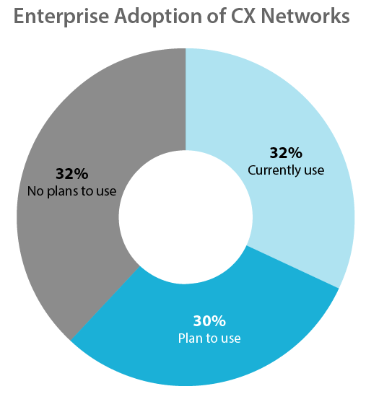

Normally red and orange used for error and warning situation. Changed was necessary.
Compare to the pie chart with donuts chart it much more appealing. Separate text and gap make it harder for the user to compare.

6. Make sure don’t make your user and readers think!:

Like the above pie chart example. So many colours used here, and user and reader have to do double shift their eyes with text and pie chart Get rid of them, data visualization grasshopper!

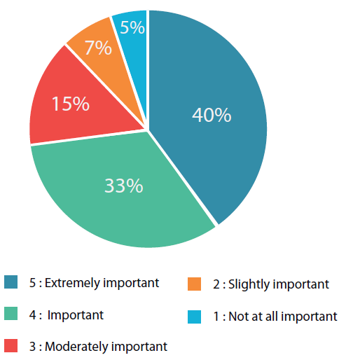

The Redesign:

First hanged from pie to donuts chart. I personally like it and it gives user and reader more ease to read and think at the same time while they are scanning.

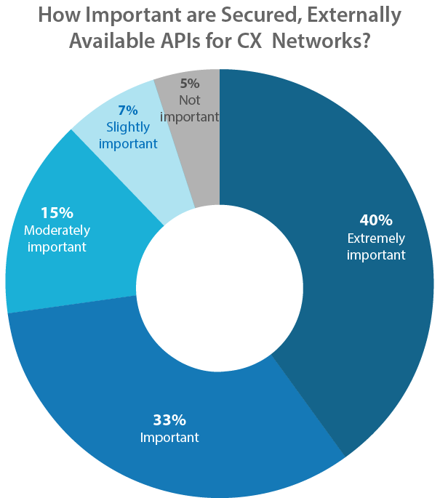
7. Choose the right colour selection and size:

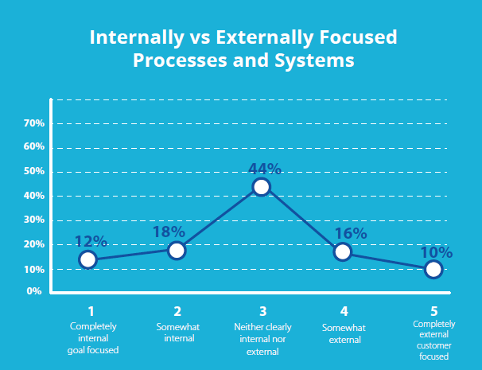
What is important here that they are trying to pass? Could we get any more boring than this?
Everything in the graph is bold, which means that nothing will be paid attention to by the reader. Nothing stands out, because everything here stands out!

The Redesign:
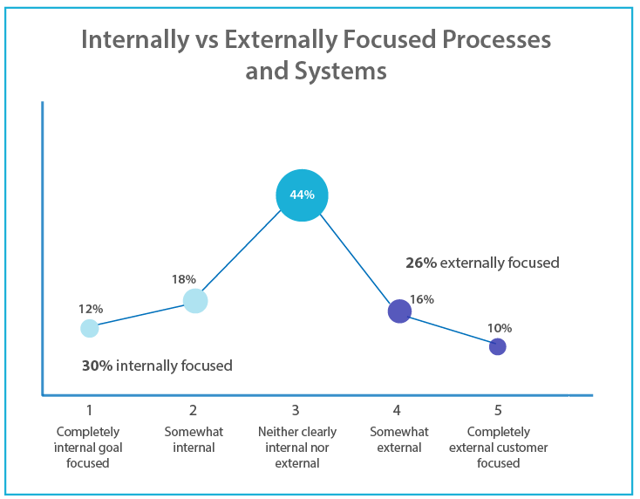
This is probably one of my favourite redesigns. Here, I used a light saturated blue colour to show internal focus increasing to a stronger saturated blue to focused.

I have also used size to convey immediately where most companies are.
And by grouping internal and external into two different blues colours and totalling the total percentages of each.

Conclusion:
It's not the ink, it's the think. It takes a tiny amount of time to really look at the data you are presenting, really think about what you are trying to say and identify the singular point using the most optimal visual.

I believe we should present our data as effectively as possible in order to first build our integrity and credibility second to set ourselves apart from everyone else who is our competitor, and third allow our leadership teams to understand the singular important point that we are trying to make so that the discussion moves very quickly with the insights.

Hope you’ve enjoyed about data visualization and its importance in conveying information and especially, in getting them to read and more importantly, understand it. Good data visualization makes your company look good!

The ideas in this post are meant to be guidelines, not final words in the world of visualization. While these rules can help you make a good chart, a great chart take so much more. Knowledge of your data, Passion for what you do and Genuine focus on your audience’ needs can make your chart truly outstanding.

Reference:
[1] How to Lie with Statistics by Darrel Huff, October 1993
[2] Turning Numbers into Knowledge: Mastering the Art of Problem Solving by Jonathan G. Koomey PhD, April 2008.
[3] Advanced Presentations by Design: Creating Communication that Drives Action by Andrew Abela, September 2008
[4] https://eazybi.com/blog/data_analysis_and_visualization/
[5] Practical Rules for Using Color in Charts http://www.perceptualedge.com/articles/Whitepapers/Communicating_Numbers.pdf
[6] Some finer points of data visualization -http://www.storytellingwithdata.com/blog/2012/09/some-finer-points-of-data-visualization
[7] Evaluation of Visualization by Critiques- https://dl.acm.org/citation.cfm?id=2993904
[8] Ten reasons to use colour. http://understandinggraphics.com/design/10-reasons-to-use-color/
[9] Using Data Visualization to Find Insights in Data http://datajournalismhandbook.org/1.0/en/understanding_data_7.html
[10] Data Visualization Inspiration: Analysis To Insights To Action, Faster! https://www.kaushik.net/avinash/data-visualization-inspiration-analysis-insights-action-faster/

